Are You Year 7 Ready?
12 Simple steps to finding your element!

Take a deep breath.
You should not be nervous; you're going to a new school that cares about its students. Your tutor and your teachers are looking forward to seeing and working with you and will always be there to help you.

Arrive on time
Plan your journey before your first day: how long will it take you to get there? And plan to arrive at least 10 minutes early. The site will be much bigger than you are used to. So, if you get lost, ask any members of staff or students to direct you to your lesson. They will be pleased to help.

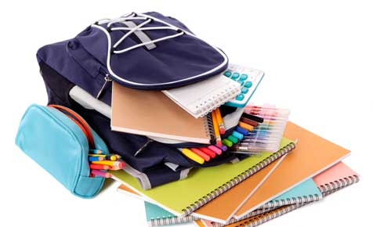 Organise your bag the night before.
This will help you be on time and feel less stressed in the morning. You are also less likely to forget important things as you would not have rushed to pack and you will sleep peacefully knowing you are ready for the BIG DAY!

Treat everyone with respect and dignity - just like you want them to treat you.
First impressions matter so from day 1, be polite and respectful. Use the right language and do what your teachers ask you to do. Don’t forget to smile –you will feel less nervous. You will make friends more easily, we love smiley and polite students

Can do attitude is KEY!
Believe in yourself. We believe in you. Trust your teachers to help you become a successful learner and follow their instructions! If you find something too difficult, tell your teacher who will help you. If you do not understand, ASK! Do not feel shy nor stupid. Teachers are there for you.

Never miss a day of school!
100% attendance = top chances of getting top grades! Even if you are feeling a bit tired or off, still come. We reward students who get 100% attendance. If you are too ill to come, you need to ensure you catch up any work you have missed in order not to fall behind!

Shop for your school supplies.
You will need a big enough bag for College books and equipment; it’s so important you have all the correct equipment for each lesson including your planner. Lockers will be provided at a cost of £_____ – keys will be issued within the first week of term in September.

Speak to Miss Simpson
If you have any issues with your peers or are unhappy in lessons or School. We are all here for you and will always make sure you feel safe and happy because we care.

Always smartly dressed.
Wear your full uniform. To look smart helps to feel and act smart. When you wear your full uniform you will feel better ready for learning. If for any reason you are missing a part of your uniform, (tie, shoes, blazer) then a letter should be provided by home and you must see your Head of Year for a uniform pass.

Bring phones to school at your own risk!
You are welcome to use your phone before school starts, at break and lunch times and at the end of school. Never use your phone between lessons or during a lesson if you haven’t been told by the teacher it is ok otherwise your phone will be confiscated.

Read Often
During the summer read and revise to feel ready on the 1st day. Throughout the year always complete your work in class and your homework to help you progress and feel happy in lessons. Write down your homework timetable in your planner – don’t forget to record homework in your planner when it is issued. It is important you write down exactly what you have to do.

You can visit the Pasta Bar or Bistro
At breakfast, break and lunchtime to purchase healthy snacks and nutritious meals. Packed lunches can be eaten in either the social areas or the Bistro but please clear up your rubbish by using the bins provided.

