Student Passport to Year 7
Summer Term

Please bring this with you on the first transition day
This is your chance to share with us any additional information about yourself. This will help teachers with lesson planning; seating plans so you can get the best possible chance at achieving your best at Biddenham International School and Sports College.
Try our best to answer every question in detail.
Here Goes….

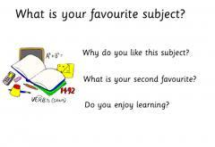

I learn best when I …

I am really looking forward to meeting you
I am really looking forward to meeting you Miss Simpson

